1. Insert the USB cable into the USB port and use an SMA cable to short-circuit TX and RX (not necessary):
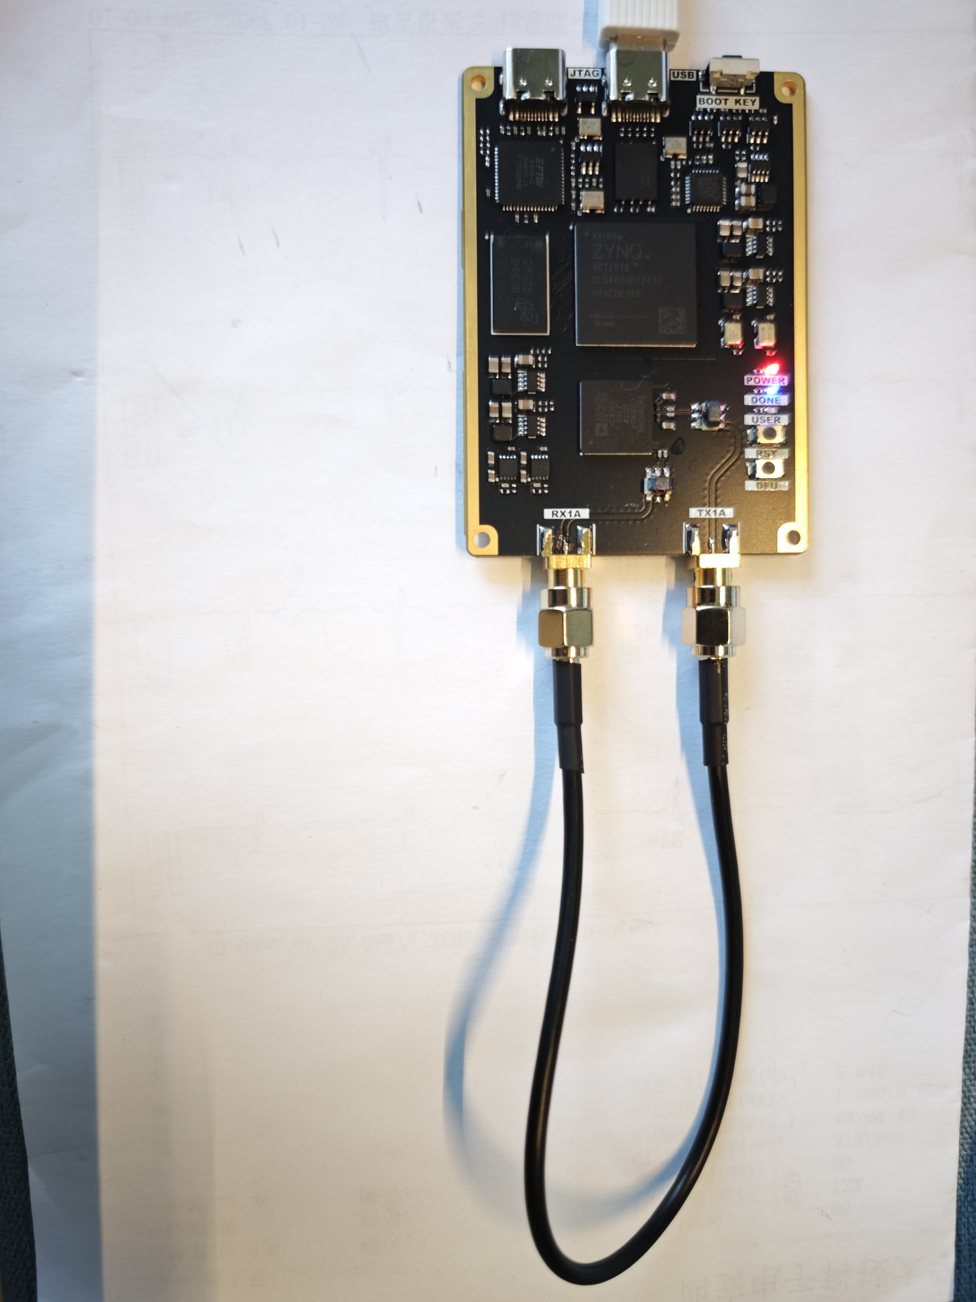

2. Wait for a moment, the USER light on the board flashes, and the computer pops up the PltuoSDR device:
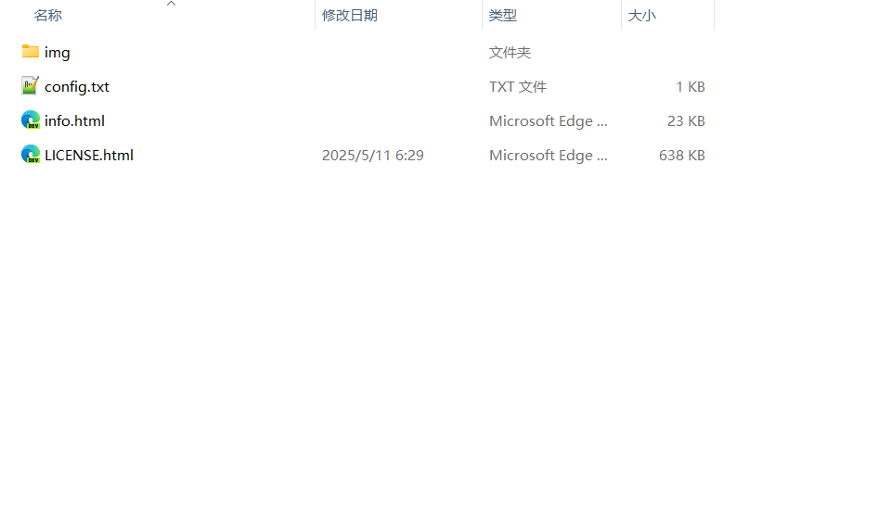
3. Open the IIO Osc software, locate the device, and connect it (the driver in the documentation needs to be installed in advance):
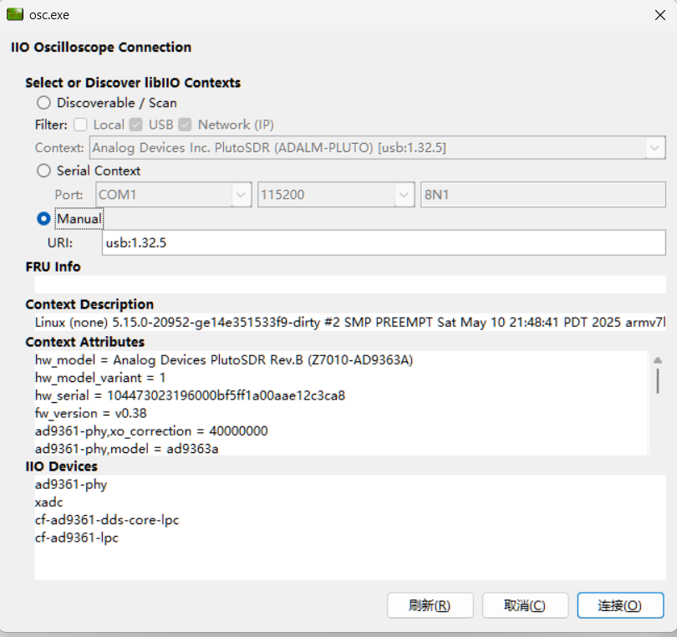
4. Set the TX1 parameter and open Plot Channels to see the waveform:
